**How to install Apache Flink on your system**

* Download apache flink from the website according to your scala and hadoop version.

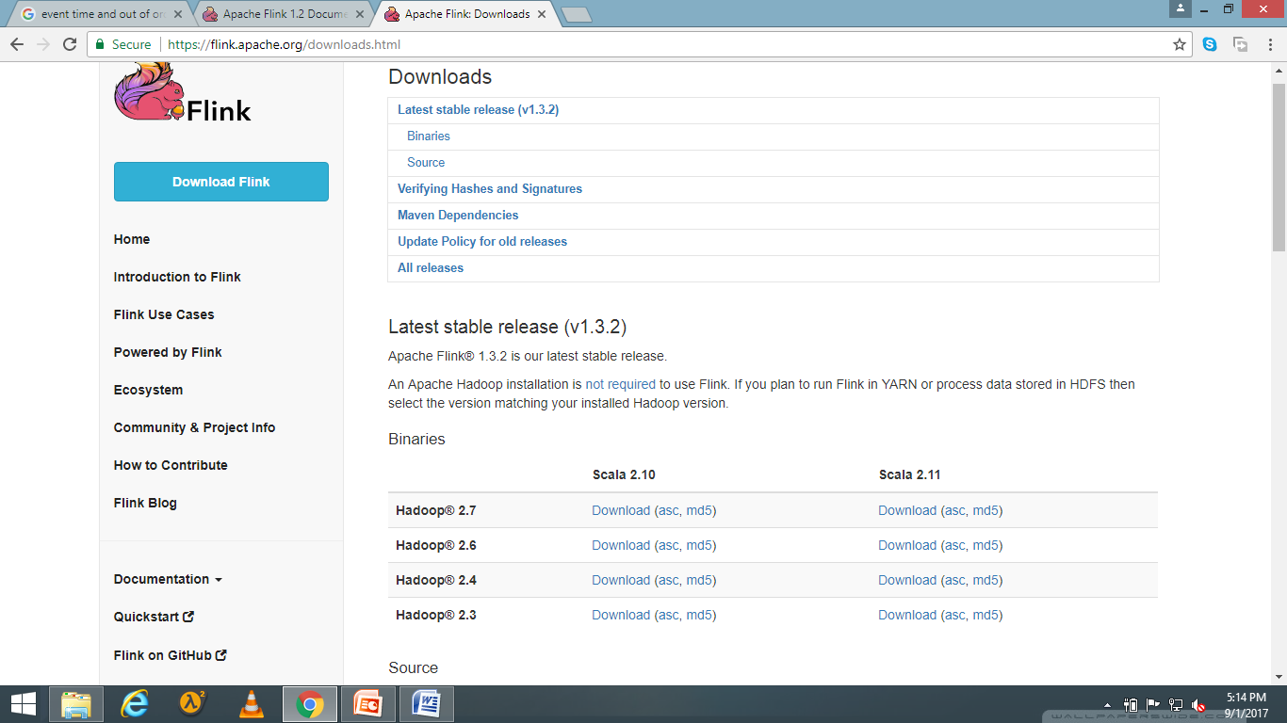

* After downloading, untar the file using command

**tar –xzf flink.1.3.2-bin-hadoop27-scala_2.11.tgz**

* Now rename it using **sudo mv flink-1.3.2 flink**
* Now move the file from the current folder to user local using

**sudo mv flink /usr/local/**

* Now provide a path in the bashrc so that you don’t need to visit it everytime you run Flink

**gedit .bashrc**

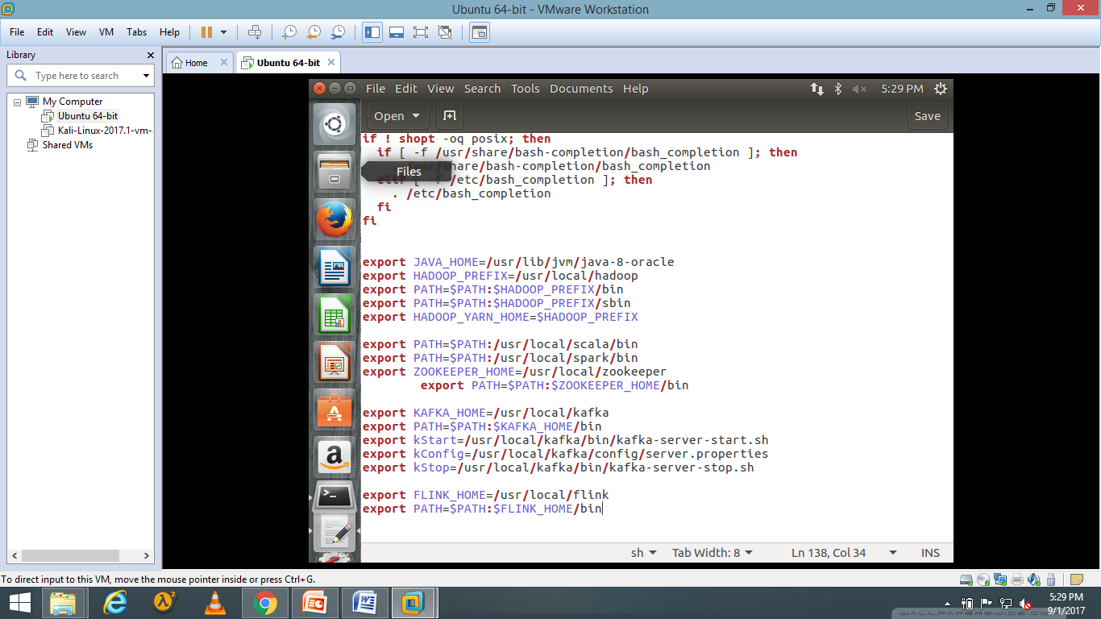

**source .bashrc**

* Now to check the commands type

**cd /usr/local/flink/bin;ls**

* Start it on localmode using

**start-local.sh**

